Report by: 1409046  
Role: Level Design & Artist liaison

Game Version: Latest – with Menus  
Date Reported: 02/05/2016

QA Status: Passed

Severity: Minor

Priority: Moderate

Test Introduction:

The purpose of this test was to see if the main menu was correctly linked to the vehicle select and then in turn linked to the corresponding level. To test this, I started the game from the ‘Main Menu’ scene and tried to play through from there.

Expected outcome:

I expected the levels to load exactly the same as if I were playing the scene directly from the editor.

Actual outcome:

When I loaded the main menu scene, the links to everything from this worked correctly. When selecting the first ship the scene loaded but the directional light was turned off, so the scene seemed as if it was in a shadow the whole time.

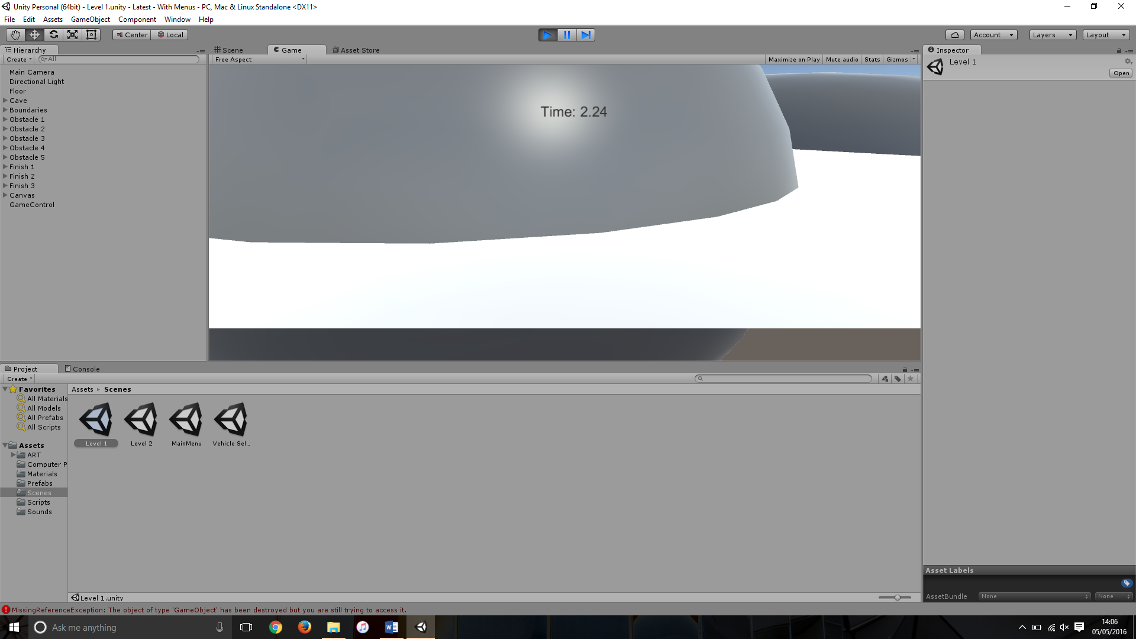Screenshot of the bug:

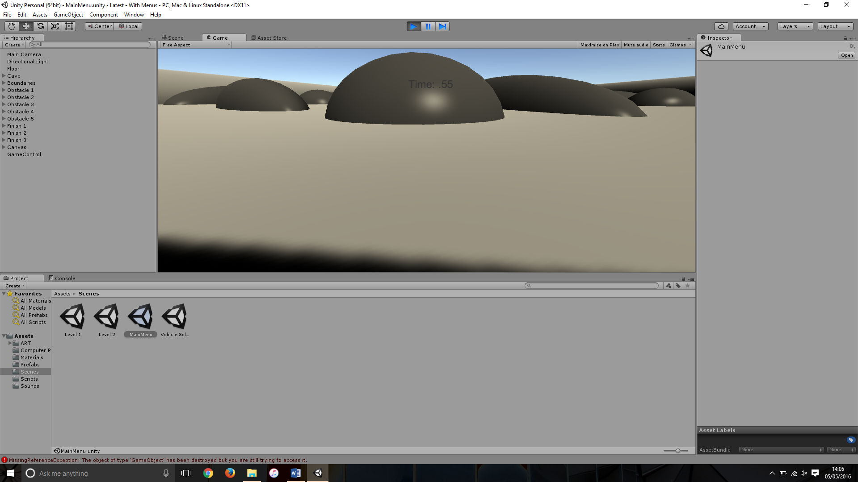Image comparison between loading scene via game menus(LEFT) and through editor(RIGHT)

Potential cause:

A potential cause of this could be that there is already a directional light turned on from the previous scenes so is overriding the new one.

Another potential cause of this is the continuous baking of the lighting, as It is set automatically it struggles to re-bake the same lighting causing a darker tone.

Suggested Fix:

To fix this bug I had to disable continuous baking of the lighting by turning off auto building the lighting and adding a light snapshot to the lightmap field.